Tutorial 2 Enhanced ER modeling

Objectives:
Revise concepts of ER and EER modeling
Use of MS Visio as a tool for creation of EER models in UML notation
Develop Enhanced ER models based on case studies

- Describe what a superclass and a subclass represent.
- Discuss the two main types of constraints on specialization/generalization.
- Discuss how to determine multiplicity constraints for relationships higher than 2. Consider the following ER diagram:

Ternary relationship multiplicity constraints
Improve the ER diagram on Fig. 1 based on the description provided below, add multiplicity constraints.
Same part could be supplied only by one supplier for the certain client, clients might order many different parts supplied by different suppliers. It is necessary to store minimal quantity of each part supplied to the client.
Draw the improved version of ER diagram in MS Visio or draw.io.
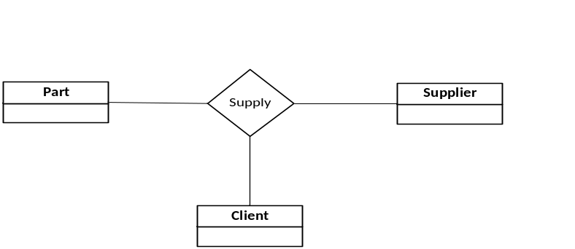
Figure 1
For each of the following case studies you will need to produce Enhanced ER diagram using UML notation in MS Visio or draw.io.

Company database
Consider the company ER schema on Fig. 2. You are required to improve that schema according to description below and introduce EER concepts where appropriate.
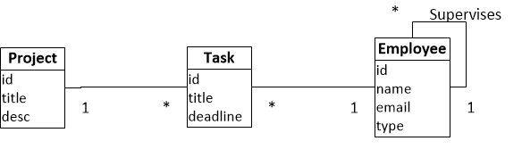
Figure 2
The company employs a number of employees; each employee could be a project manager, developer, senior developer or tester. All employees are assigned to certain projects, project could involve many employees and employee could work on more than 1 project but not more that on 5 projects.
Each employee is assigned a set of tasks. Tasks could have types “testing” and “development”. Testers should be assigned only “testing” tasks and developers only “development” tasks. Each task belongs to certain project. One task could be assigned to one employee only.
Project managers supervise projects, each project could be supervised by 1 project manager and project managers are allowed to supervise up to 3 projects. Senior developers could supervise a set of developers.
For each project it is also necessary to store information about a company which is ordered it. For each company it is required to store company name, address, web site URL and a set of company contact persons with their emails, phone numbers and full names.
Sometimes company contact persons might want to introduce changes to projects that their company ordered. For each change it is required to organize a meeting between specific company contact person and a project manager. Each meeting should be recorded in database and it is required to store meeting date, meeting notes, who participated and what project was discussed.

The EasyDrive School of Motoring
The EasyDrive School of Motoring was established in Glasgow in 2009. Since then, the School has grown steadily and now has several offices in most of the main cities of Scotland. However, the School is now so large that more and more administrative staff are being employed to cope with the ever-increasing amount of paperwork. Furthermore, the communication and sharing of information between offices, even in the same city, is poor. The Director of the School, Dave MacLeod, feels that too many mistakes are being made and that the success of the School will be short-lived if he does not do something to remedy the situation. He knows that a database could help in part to solve the problem and has approached you and your team to help in creating a database application to support the running of the EasyDrive School of Motoring. The Director has provided the following brief description of how the EasyDrive School of Motoring operates.
Each office has a Manager (who tends to also be a Senior Instructor), several Senior Instructors, Instructors, and administrative staff. The Manager is responsible for the day-to-day running of the office. Clients must first register at an office and this requires that they complete an application form, which records their personal details. Before the first lesson, a client is requested to attend an interview with an Instructor to assess the needs of the client and to ensure that the client holds a valid provisional driving license. A client is free to ask for a particular Instructor or to request that an Instructor be changed at any stage throughout the process of learning to drive. After the interview, the first lesson is booked. A client may request individual lessons or book a block of lessons for a reduced fee. An individual lesson is for one hour, which begins and ends at the office. A lesson is with a particular Instructor in a particular car at a given time. Lessons can start as early as Sam and as late as 8pm. After each lesson, the Instructor records the progress made by the client and notes the mileage used during the lesson. The School has a pool of cars, which are adapted for the purposes of teaching. Each Instructor is allocated to a particular car. As well as teaching, the Instructors are free to use the cars for personal use. The cars are inspected at regular intervals for faults. Once ready, a client applies for a driving test date. To obtain a full driving license the client must pass both the practical and theoretical parts of the test. It is the responsibility of the Instructor to ensure that the client is best prepared for all parts o the test. The Instructor is not responsible for testing the client and is not in the car during the test but should be available to drop off and pick up the client before and after the test at the Testing Centre. If a client fails to pass, the Instructor must record the reasons for the failure.

Video Rental Company
The video rental company has several branches throughout the USA. The data held on each branch is the branch address made up of street, city, state, and zip code, and the telephone number. Each branch is given a branch number, which is unique throughout the company. Each branch is allocated staff, which includes a Manager. The Manager is responsible for the day-to-day running of a given branch, which includes management of the branch staff. The data held on a member of staff is his or her name, position, and salary. Each member of staff is given a staff number, which is unique throughout the company.
Each branch has a stock of videos. The data held on a video is the catalog number, video number, title, category, daily rental, cost, status, and the names of the main actors, and the director. The catalog number uniquely identifies each video. However, in most cases, there are several copies of each video at a branch, and the individual copies are identified using the video number. A video is given a category such as Action, Adult, Children, Drama, Horror, or Sci-Fi. The status indicates whether a specific copy of a video is available for rent. Before hiring a video from the company, a customer must first register as a member of a local branch. The data held on a member is the first and last name, address, and the date that the member registered at a branch. Each member is given a member number, which is unique throughout all branches of the company. Once registered, a member is free to rent videos, up to maximum of ten at any one time.
The data held on each video rented is the rental number, the full name and number of the member, the video number, title, and daily rental, and the dates the video is rented out and date returned. The rental number is unique throughout the company.

Art museum
Design a database to keep track of information for an art museum. Assume that the following requirements were collected:
- The museum has a collection of art objects. Each art object has a unique idno, an artist (if known), a year (when it was created, if known), a title, and a description. The art objects are categorized in several ways as discussed below.
- Art objects are categorized based on their type. There are three main types: painting, sculpture, and statue, plus another type called other to accommodate objects that do not fall into one of the three main types.
- A painting has a paint type (oil, watercolor, etc.), material on which it is drawn on (paper, canvas, wood, etc.), and style (modern, abstract, etc.).
- A sculpture has a material from which it was created (wood, stone, etc.), height, weight, and style.
- An art object in the other category has a type (print, photo, etc.) And style.
- Art objects are also categorized as permanent collection that are owned by the museum (which has information on the date acquired, whether it is on display or stored, and cost) or borrowed, which has information on the collection (from which it was borrowed), date borrowed, and date returned.
- Art objects also have information describing their country/culture using information on country/culture of origin (Italian, Egyptian, American, Indian, etc.), epoch (renaissance, modern, ancient, etc.).
- The museum keeps track of artist's information, if known: name, date- born, date died (if not living), country of origin, epoch, main style, description. The name is assumed to be unique.
- Different exhibitions occur, each having a name, start date, end date, and is related to all the art objects that were on display during the exhibition.
Draw an EER schema diagram for this application. Discuss any assumptions you made, and that justify your EER design choices.

Home work
- Provide multiplicity constraints for ER diagram displayed below. You should make your own assumptions and provide multiplicities that would match your assumptions.
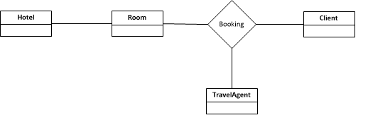
- Design EER diagrams for all the case studies that you will not manage to complete during tutorial.

